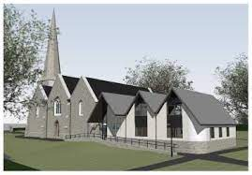

OUR PARTNERSHIP IN GOD’S MISSION IN THE WORLD

Jesus said:” …. you will be my witnesses in Jerusalem, and in all Judea and Samaria, and to the ends of the earth.”
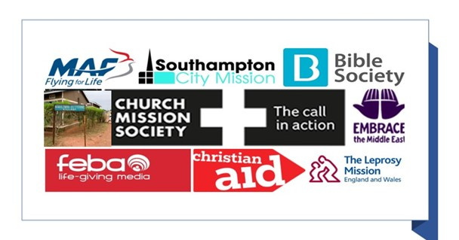

Today we are Jesus’ witnesses in Bitterne, and in all of Southampton and the UK, and to the ends of the earth.

Weeks 1 to 6 Partners in Mission
Name of Society
NAMALEMBA and BUMOOZI PARTNERSHIP (With THE BUSOGA TRUST)
The Aim
The vision of the Parish and the two communities is to demonstrate the love of Jesus by praying for each other and helping to provide Water, Sanitation and Health to these communities in rural Africa.
The activities that we support.
The Parish has regularly supported the work of Health Centres in Namalemba and Bumoozi. Parishioners helped build the earlier Health Centre in Namalemba which has now been replaced and where upgrading and the provision of additional staff could result in it being adopted by the government. We support the Health Centre in Bumoozi, paying the salaries of the two nurses and topping up the cost of drugs. In October 2021, we paid for electricity to be installed in Bumoozi Health Centre. In April 2022 we are supporting a number of items in Namalemba, including solar panels and the construction of an operating theatre. As part of our commitment to the area we have helped provide clean water to many homes, through the installation of water collecting tank, and sanitation, mainly using the engineers and expertise of the Busoga Trust, which we continue to support.
Our local contact
Ian Ward or Ricky Yardley
The name(s), location and type of work undertaken by any ‘front line’.
Holt Saviour’s direct contacts are Charles Kibumba, Chairman of Namalemba Development Committee, Samuel Kakaire, Chairman in Bumoozi. But we are blessed with many good friends there with whom we share the blessing of this partnership.
Click to go to the website busogatrust.co.uk
This link takes you to the service where Ian and Sue Ward presented our work with Namalemba, with up to date photos and news.
https://ms-my.facebook.com/HolySaviourBitterne/videos/namalemba-mission-sunday-11am/3101734940074229
The reason(s) why the church family support the organisation in the 2020s
Over involvement began over thirty years ago when English Dioceses began ‘twinning’ with dioceses overseas. Winchester twinned with Uganda, our Deanery twinned with Busoga Diocese and our parish with Namalemba and Bumoosi. This became an active link with a real involvement in support for work in Namalemba and personal contacts. Over the years many people from Bitterne have visited and stayed in Namalemba, and more than ten people from Namalemba have been here in Bitterne, living in people’s homes and being welcomed by the community. These experiences alone explain the warmth and 30-year life of our link. The main financial support for our work in Namalemba has come from individual giving. + 10% of Traidcraft sales and Bible reading notes sales, as well as a share of our mission funding.

Week 1 Prayer
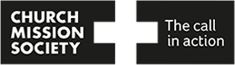
Name of Society
CMS, THE CHURCH MISSION SOCIETY
The Aim
By joining in God’s mission, through Jesus, and in the power of the Spirit CMS see that: the love of Christ renews people and places; pioneering leaders forge new paths of transformation; people on the margins flourish; the healing of creation begins. CMS believe that all of God’s people are called to join in God’s mission – whether that means going overseas or over the road – and works to set people free to put this call into action.
The activities that we support.
CMS-Africa where the leaders believe that for true life transformation to take place, it all has to begin with mindset change: Away from poverty, towards recognising available, abundant, local resources; away from a Sunday-only Christian faith, towards whole-life deep discipleship; Away from relying on outsider aid, towards loving your neighbours.
Asia-CMS which is focussed on those people-groups who do not yet know the gospel of Jesus and on spheres of God’s mission that have been overlooked in Asia. Asia-CMS fosters collaboration in mission and the Church Mission Society is seeking to join them “Together on the Edge in God’s Mission”.
In Latin America, where it was the South American Missionary Society who pioneered the work until they linked with CMS, CMS works closely with local churches and Christian organisations, seeing a Latin America mission community emerge.
Our local contact
Sandra Payne (A new representative is needed as Sandra is retiring from this post).
The name(s), location and type of work undertaken by any ‘front line.
‘The Parish has supported David Sharland, an agriculturist in Africa, for at least 35 years and for the past 22 years, both David and his wife Heather, a health worker and midwife. David and Heather retired at the end of February 2022. In addition, the Parish has supported a number of mission workers in South America for around 35 years and we are currently waiting for confirmation of new partners in South America.
Click to go to the website churchmissionsociety.org
The reason(s) why the church family support the organisation in the 2020s
Bitterne church has been linked with CMS for many years, the work it does is very valuable and worthwhile. Over the years, church members have had the privilege of getting to know our many Mission Partners through their newsletters and visits to the church. This gives a very personal interest for church members and many feel that these people have become friends and look forward to the regular updates. In 1995 four church family members were fortunate to visit David Sharland in Zaire (the Democratic Republic of Congo as it is called now) and to see the work he did for ourselves. Supporting CMS and having link mission partner(s) makes more personal than just partnering with an organisation. The link allows us to see all God’s people engaged in God’s mission, bringing challenge, change, hope and freedom to the world

Week 2 Giving

Name of Society
Bible Society
The Aim
To bring the Bible to life; to help people around the world engage with it, relate to it, and make sense of it.
The activities that we support.
200 years ago in North Wales, Mary Jones walked 26 miles to buy a bible from Rev Thomas Charles. Her action led people to see the need for the formation of Bible Society! Today Bible Society is a Christian charity on a mission to offer the Bible to the world, which believes that when people engage with the Bible, lives can change for good. Bible Society seeks to follow their mission through projects, using translation, distribution, creating digital formats, advocacy for the place of the Bible and Scripture engagement all over the world.
Our local contact
Jan Parfitt
The name(s), location and type of work undertaken by any ‘front line.
Now it is a major publisher and distributor of Bibles not only in English and Welsh but many other languages too. It supports many Bible Societies and their bookshops in countries where access to the Scriptures is far more difficult than for us in the UK. One of their big projects is ‘A Bible a Month’ through which supporters can sign up to fund a copy of the bible every month for distribution in other countries. Amongst other activities they also produce resources, run an on line shop and work together with ‘Open the Book’, which promotes and trains groups of lay people to take Christian worship into schools through drama. We have had regular visits from representatives of the Society at our services. A major project in the UK in recent years has been the development and promotion of the Bible Course which we have run in Bitterne.
Click to go to the website biblesociety.org.uk
The reason(s) why the church family support the organisation in the 2020s
We believe that the Bible is God’s Word to us, so we should promote and support those who are aiming to make God’s word more accessible around the world.

Week 3 Caring
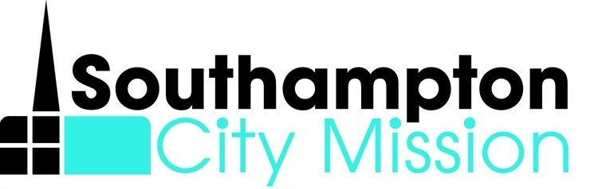
Name of Society
SOUTHAMPTON CITY MISSION
The Aim
An independent Christian mission working with churches in Southampton to deliver exciting schools work & provide emergency food & clothing through SCM Basics Bank.
The activities that we support.
As a church we currently have a food bank donation point, regularly encourage the congregation to give in this way. We also usually have SCM as our Harvest donation appeal both in terms of food and money donations. WE usually collect Christmas presents for children at our Toy service
Our local contact
Duncan House leads SCM and is who we link directly with when needed.
The name(s), location and type of work undertaken by any ‘front line’.
Sholing St Mary’s is our nearest foodbank running on Tuesdays – both Ruth Palmer and Ian Wilkinson are supervisors there.
We benefit as a school community from the Question of Faith days that SCM run with Ruth Palmer and Barry Brand part of the local team which support this input into the curriculum.
Click to go to the website southamptoncitymission.co.uk
The reason(s) why the church family support the organisation in the 2020s
We believe that it is so important to help support the least, the lost, the hurting and the broken not only abroad but also locally too. SCM do a fantastic job of bringing the Good News of Jesus in practical and spiritual ways across the City to those most in need. This is a really simple and accessible project that we can fully get on board with.

Week 4 Suffering
Name of Society
CHRISTIAN AID
The Aim
A global movement of people, churches and local organisations. inspired by the teachings of Jesus.
The activities that we support.
Christian Aid was founded in 1945 to help refugees after the 2nd World War. Their vision is to create a world where everyone can live a full life, free from poverty. As a faith-based organisation, anchored in church congregations and a network of partnerships across the world, Christian Aid aims to create a movement of people who passionately champion dignity, equality, justice and love
Our local contact
Sue Daw
The name(s), location and type of work undertaken by any ‘front line
Christian Aid works with some of the world’s most vulnerable communities in Africa, Asia, the Middle East, and Latin America and the Caribbean. It always works through local partners, strengthening peace-building, promoting resilient farming, challenging inequality, empowering women and promoting their rights, justice and peace building, ensuring people can access the services they need, and adapting livelihoods to climate change. When emergencies strike in these countries, they are there before, during and after, to save lives and support people in the long term. It is one of the members of the DEC (Disasters Emergency Committee) which responds to and raises funds for the major emergency situations around the world.
.Click to go to the website christianaid.org.uk
The reason(s) why the church family support the organisation in the 2020s
It provides opportunities for us to take action, campaign, give and pray for our less fortunate neighbours throughout the world. We also have an opportunity to work together with local churches during Christian Aid week. As Christians we are called to love our neighbours and put our faith into action. ‘Let us love, not in word or speech but in truth and action’ (1 John 3:18).

Week 4 Suffering (Continued)
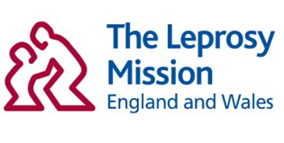
Name of Society
THE LEPROSY MISSION

The Aim
A global Christian organisation leading the fight against leprosy. Following Jesus Christ, we seek to bring about transformation, breaking the chains of leprosy and empowering people to attain healing, dignity and life in all its fullness.
The activities that we support.
The Parish supports Leprosy Mission Sunday and encourages members to buy items on their website. Philippa Matthews is recognised as a Trading Representative for the Society
Our local contact
Philippa Matthews
Chris Stratta is the regional representative
The name(s), location and type of work undertaken by any ‘front line.
The Leprosy Mission is a global Christian organisation leading the fight against leprosy.
Following Jesus Christ, It seeks to bring about transformation; breaking the chains of leprosy and empowering people to attain healing, dignity and life in all its fullness.
It believes no one should suffer because of a preventable and treatable disease.
It works with people of all faiths and none to defeat leprosy and transform the lives of people affected.
The Leprosy Mission’s Global Fellowship works in 28 countries. The British focus is on ten countries in Africa and Asia - Bangladesh, Ethiopia, India, Mozambique, Myanmar (Burma), Nepal, Niger, Nigeria, Sri Lanka and Sudan. These places have high rates of leprosy or lack the services or opportunities needed by people affected.
As well as supporting people living with leprosy today, we serve future generations by working to end the transmission of the disease. So they may be born into a world free from leprosy.
Click to go to the website leprosymission.org.uk
The reason(s) why the church family support the organisation in the 2020s
The Parish cares about the work that the Leprosy Mission does for those people who still suffer from consequences of Leprosy.

Week 5 Going
Name of Society
FEBA RADIO (originally the Far East Broadcasting Associates)
The Aim
The ministry is all about the creative use of radio and other audio media to inspire people to follow Jesus Christ.
The activities that we support.
Our funding goes to help resource all of FEBAs projects around the world where the use particularly of radio media (Shortwave, Medium Wave, FM), as well as internet and social media, is used to spread the Word of God within areas of Christian suppression in Asia, Africa and the Middle East. FEBA also operates in regions in the aftermath of a natural disaster providing information on where people can find food water and shelter as well as emergency services.
FEBA works in partnership with local organisations giving funding, engineering expertise and well as the provision of specialist equipment so that transmissions are made in local languages and dialect that the listeners can understand.
Our local contact
Adrian Jacobs
The name(s), location and type of work undertaken by any ‘front line.
Closer to home FEBA are working with FEBC Ukraine to provide a message of hope within the country throughout the Russian invasion, providing vital radio links to those that are cut off from family and importantly to those serving on the front line, The team are offering prayer and psychological support. As they follow up with listeners who are terrified through phone calls and messages, sharing scripture on air and if required provide practical support lifesaving information and advice.
Click to go to the website feba.org.uk
The reason(s) why the church family support the organisation in the 2020s
Radio remains an important and sometimes only form of communication for communities that are isolated either geographically or through suppression, natural disasters or conflict. The use of radio enables the Word of God and a sense of hope to those that so desperately need it

Week 5 Going (Continued)
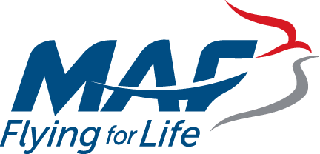
Name of Society
MISSION AVIATION FELLOWSHIP
The Aim
To spread the Good News of Jesus to remote places. This is achieved by offering a flying service for people and cargo. In practice they operate a fleet of 120 light aircraft able to land on dirt strips. They are funded by charitable donations and direct payment for flights. Ferrying local people and casualties to hospital would be free.
The activities that we support.
We support MAF Europe based in Folkstone, they fly in Africa and Asia. MAF Australia are responsible for Northern Territories and Pacific Islands. USA looks after South America.
Our local contact
Ricky Yardley.
The name(s), location and type of work undertaken by any ‘front line’ .
The Parish does not support any individuals, but MAF employ Head Office staff in the UK and in the field there are many engineers, ground staff, and highly trained “bush” pilots. They have to fly without the help ground aids and in small airstrips in jungle setting but with the ever threat of violent tropical rainstorms. They fly missionaries, health and aid workers, even government officials at times, to places which would be hard to reach by road in inhospitable circumstances, making journeys that could take many hours, even days, feasible. They also undertake Medevac evacuations, transporting people to hospital in emergency situations.
Click to go to the website maf-uk.org
The reason(s) why the church family support the organisation in the 2020s
Our support was born out of our experience of our parishioners using MAF in 1995 to visit our CMS partner David Sharland in Zaire (now the Democratic Republic of Congo) an agriculturist. So we saw what important work they did then and still continue to do.

Week 6 Longing
Name of Society
EMBRACE the MIDDLE EAST (formerly Bible Lands Society).
The Christian development charity tackling poverty and injustice in the Middle East
The Aim
A vision of love in action. It is rooted in, and inspired by, Christ’s invitation to care for those most in need. Enbrace’s goal is to contribute to a culture of human flourishing in a troubled region
The activities that we support.
Holy Saviour supports Embrace’s vision to support Christian partners reflects the mission of the worldwide church as their partners proclaim the Good News through education, health care, refugee services, valuing creation, and speaking up for justice and human rights.
Our local contact
Sue Daw
The name(s), location and type of work undertaken by any ‘front line.
Partnership is at the centre of Embrace’s vision of transformation. Their work centres on the Holy Land, with many projects around Bethlehem and the West Bank, but extends to other counties such as Lebanon, Syria and Egypt. They support, enable and partner with the Middle East’s Christians. Embrace works with 50 partners in fields such as healthcare, education, and community development projects. Many of the projects focus on helping people with various disabilities, who would often not receive help or be valued in the societies of which they are a part. Others enable girls and women to gain access to education and training, to which again they would not have ready access in their local culture, enabling them to play a more capable and fulfilled role in their homes and communities.
Click to go to the website embraceme.org
The reason(s) why the church family support the organisation in the 2020s
Holy Saviour continues to support our Christian brothers and sisters working in the Middle East because we know life is still very difficult in the Holy Land. We support them because there is still a need and opportunity for them to proclaim the Good News through education, health care, refugee services, valuing creation, and speaking up for justice and human rights. The Bible tells us, “Whatever you did for one of the least of these brothers and sisters of mine, you did for me”. (Matthew 25:40)

